给了激光雷达的算法包和一个录好的包

1.mkdir catkin_ws
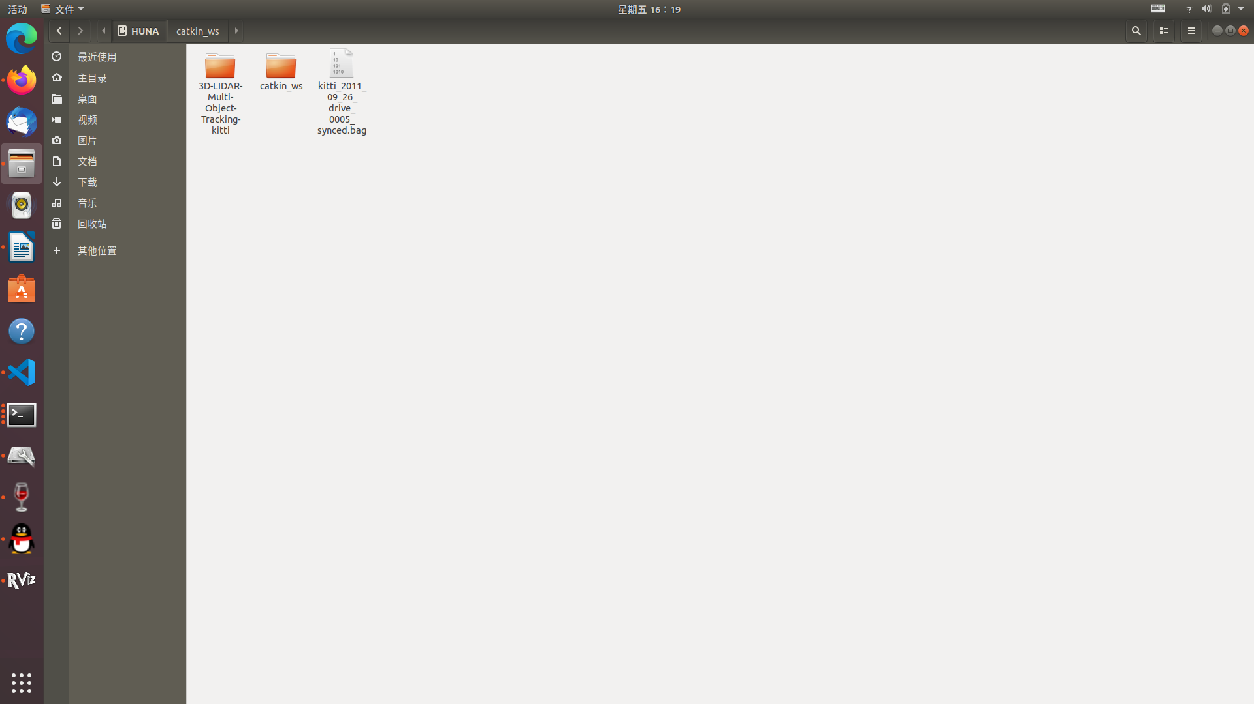
2.mkdir -p catkin_ws/src
3.cd catkin_ws
4.catkin_make
这个位置生成build ,devel文件。
将算法包中object_tracking放在catkin_ws的src里面
5.在根目录下编译

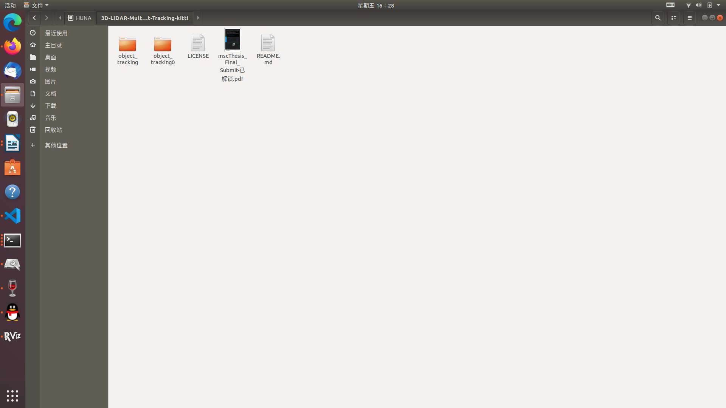

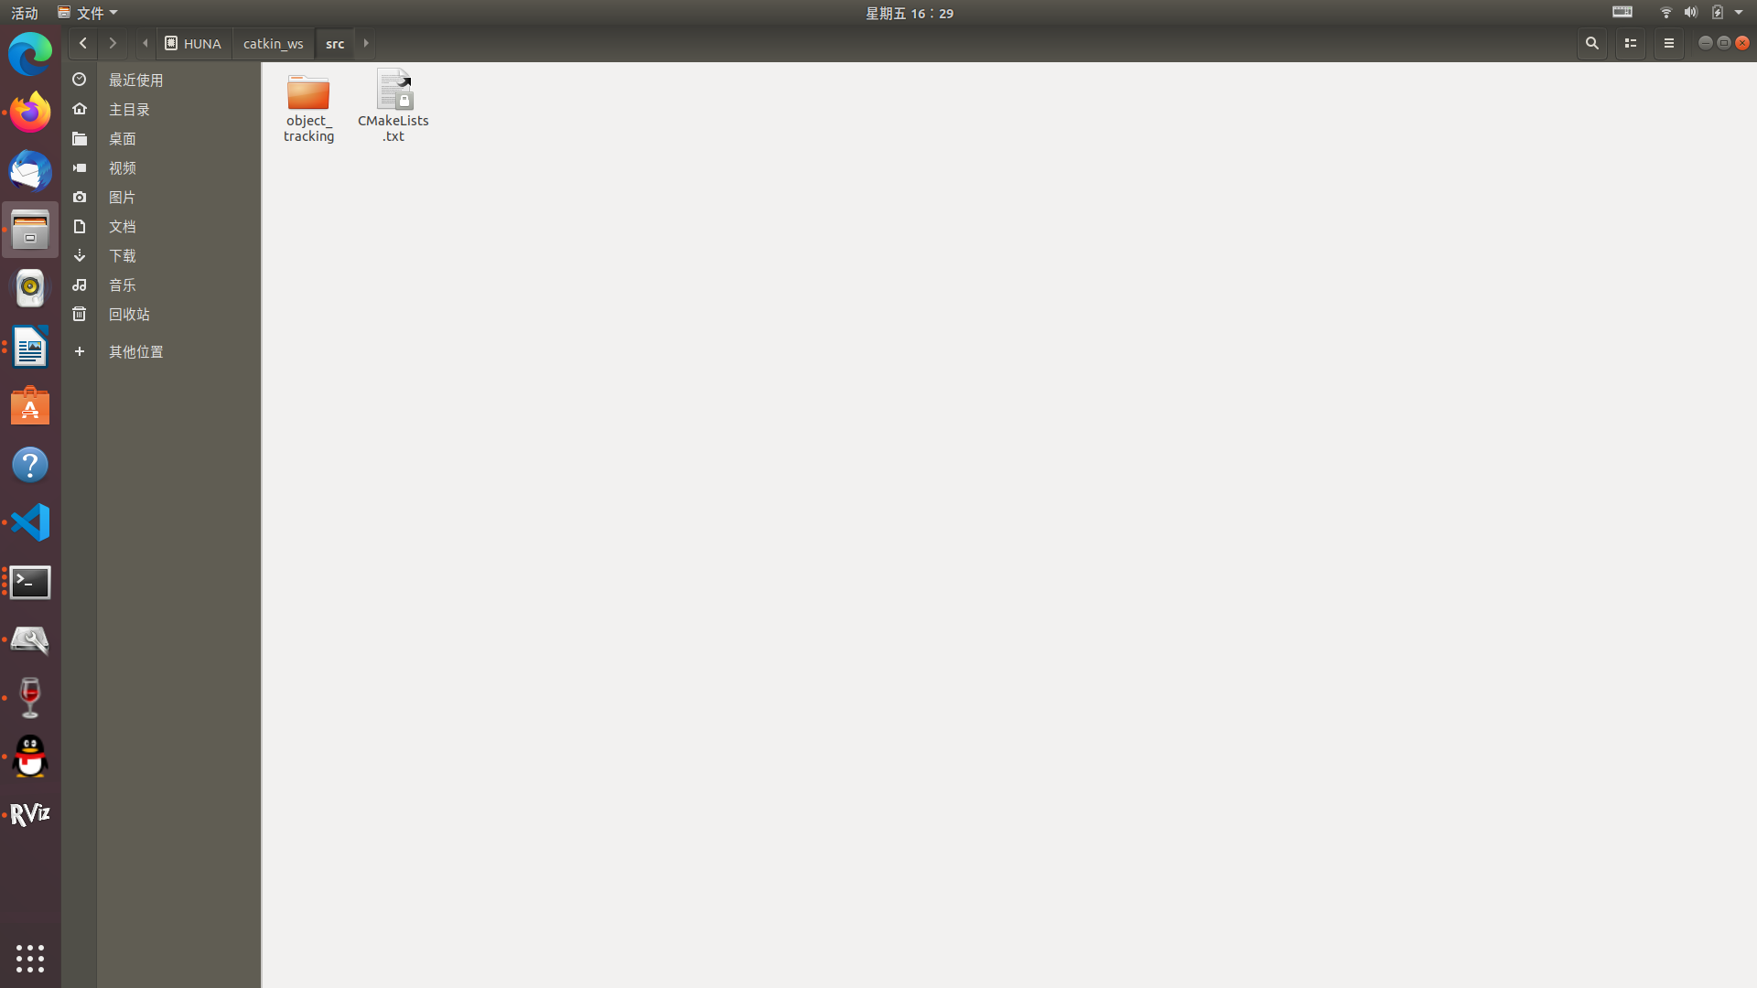
5. roscore
6.catkin_make
7.source devel/setup.bash
8.roslaunch object_tracking test.launch
6.rviz
9.rosbag play kitti_2011_09_26_drive_0005_synced.bag
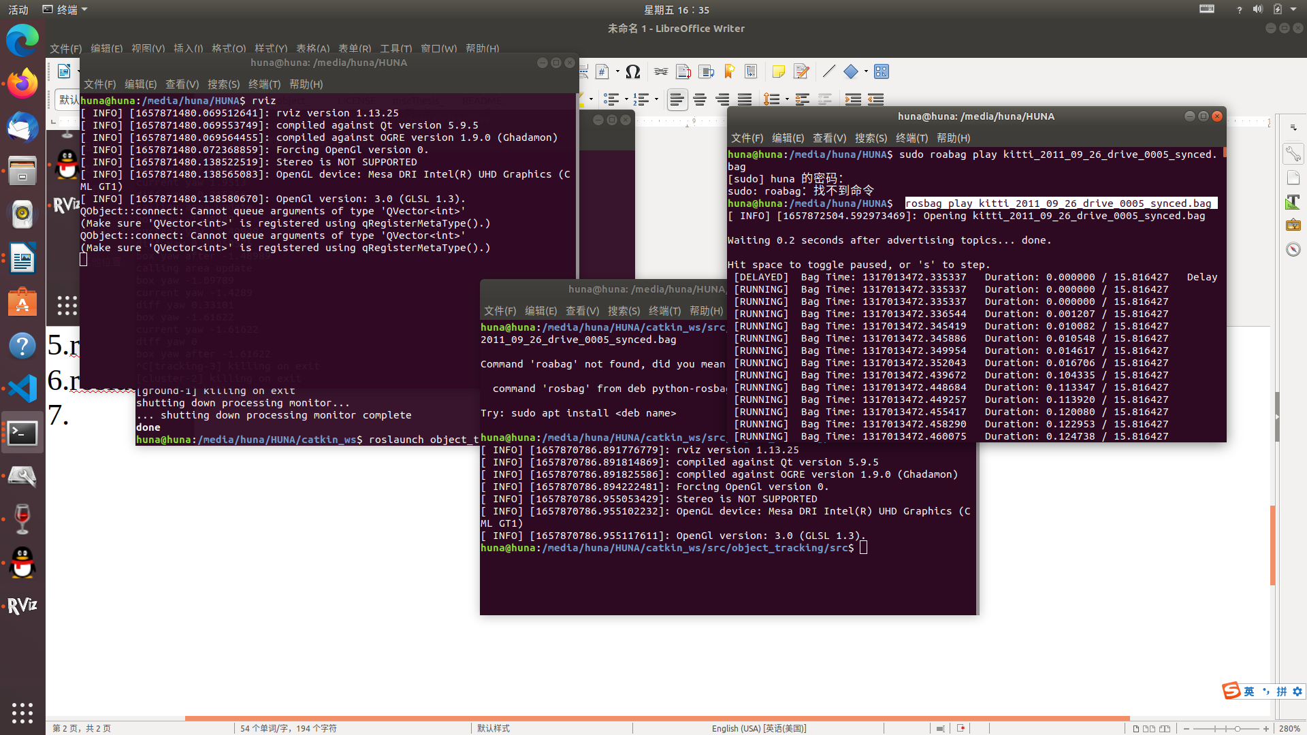
7.

